**PLCnext**

**<Totalizer_V1>**

**Version: V1**

**For PLCnext Engineer >= 2023.0.LTS**

Table of Contents

1. Overview 3

2. General Information 4

3. Change Notes 5

4. Function Blocks 6

5. FB_AverageSamples 7

# 

# 1. Overview

Basic Totalizer FB that samples Flow rate every 5 sec for a total of 12 samples and then average gives flow rate every minute.

# 2. General Information

Basic Totalizer FB that samples Flow rate every 5 sec for a total of 12 samples and then average gives flow rate every minute.

Analog Input from level sensor needs to be converted from word to UDINT.

# 3. Change Notes

|  |  |  |  |  |
| --- | --- | --- | --- | --- |
| **Library Version** | **Library Build** | **PLCnext Engineer Version** | **Change Notes** | **Supported PLC** |
| **1** | **20230820** | **>= 2023.0 LTS** | **Initial Release** | **AXC F 1152**  **AXC F 2152**  **AXC F 3152** |
|  |  |  |  |  |
|  |  |  |  |  |

# 4. Function Block

|  |  |  |  |  |
| --- | --- | --- | --- | --- |
| **Function Block** | **Description** | **Ver** | **Supported Articles** | **License** |
| Totalizer_V1 | Basic Totalizer | 1 | - | None |

# 

# 5. Totalizer_V1

Basic Totalizer Function Block for average Totalizer of 12 samples a minute.

Note: This Function Block does not parameterize or control the Module.

5.1 Change Notes

|  |  |
| --- | --- |
| **Version** | **Change Note** |
| 1 | Initial Release |

**5.2 Function Block Call**

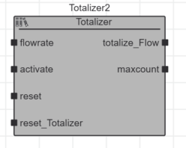

**5.3 Input Parameters**

|  |  |  |
| --- | --- | --- |
| **Name** | **Type** | **Description** |
| flowrate | UDINT | Analog Data from Module |
| activate | Bool | Activate FB |
| reset | Bool | Reset Internal clock ( Used for sampling) |
| Rest_Totalizer | Bool | Resets all values |
|  |  |  |

**5.4 Output Parameters**

|  |  |  |
| --- | --- | --- |
| **Name** | **Type** | **Description** |
| totalize_Flow | UDINT | Totalized flow count per minute |
| maxcount | UDINT | When totalize flow goes over 4,000,000,000 will increase by 1 |
|  |  |  |

Programming view

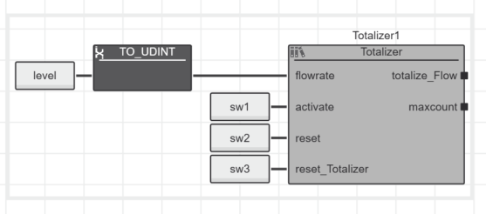

Online Debug view

